Module configuration of the
HD-SD Sync Generator

For the June 2004 sales meeting

Abstract:

The modules in question comes in two different physical dimensions. A normal and a wide module. In the following the two modules types will be highlighted with a greenish colour for the normal module size and a bluish colour for the wide module size.

Because of this module variation plus some software restrictions in how modules can be mounted it is often difficult to know which module configurations are possible or not.

According to Gunner Bækgaard some of the original modules for the current PT5210/PT5230 is actually the same PCB but offered as two different modules. One dedicated for the PT5210 and one for the PT5230. Only the software on the module defines which module type it is. And only the software controls which functions each module will be born with.
To differentiate all current modules they have been divided up in two families.
The PT860x for the PT5210, and the PT863x family for the PT5230.

It is not allowed to mix modules from the two families in the same unit.
Exceptions however is the PT8608(black burst), PT8635(AES-3 generator) PT8604(Multiple Black-Burst) and the PT8606(SDI Genlock) which are for both models.
However there is no technical reason for this restriction. This means that the HD-SD sync generator will be able to support both module families.

For these reasons we need to decide if all modules will be offered to the HD SD or only the one generating the best functionality and contribution margin. However by making such restrictions we risk only to offer the most “expensive” solution !

……..

To give a better overview on how the HD-SD sync generator can be configured the following document has created. This document does not differentiate between original PT5210 and PT5230 modules. But includes all existing modules.

Configuration 1.

Configuration 2.

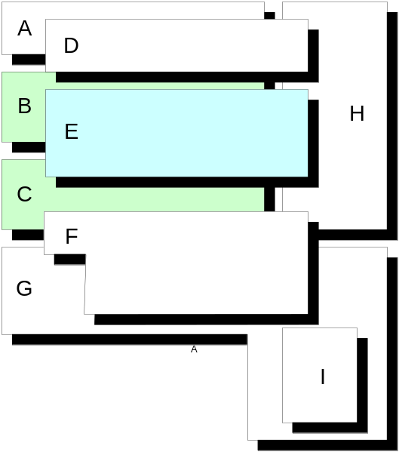
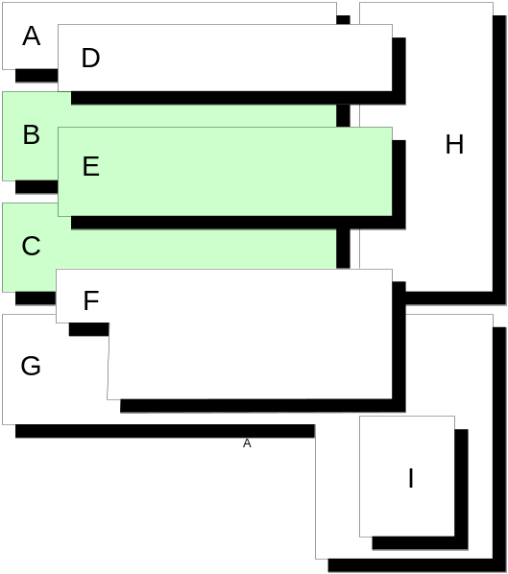
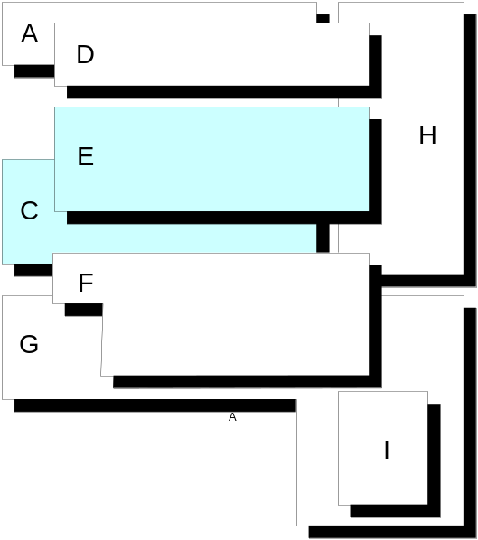
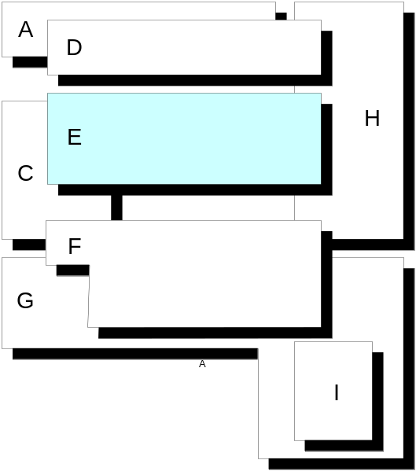

Configuration 3.

Configuration 4.

Configuration 1.

A: PT8635 Dual AES-3 Digital Audio Generator.
Only PT8635 can be mounted on this location.
Constrain: If slot B is in use by a PT8611 the AES output-2 must be moved to one of the SDI Genlock outputs(taken for granted that the SDI genlock option is not mounted in slot D)

B: PT8608 Dual Black Burst Generator.
PT8609 SD-SDI Black/Colour bar Generator.
Original basic SDI generator for the PT5210.
PT8611 Quad Tri-Level Generator.
PT8639 SD-SDI Basic Test Signal Generator.
Original basic SDI generator for the PT5230.

C: PT8608 Dual Black Burst Generator.
PT8609 SD-SDI Black/Colour bar Generator.
Original SDI generator for the PT5210.
PT8611 Quad Tri-Level Generator.
Constrain: Requires extra BNC mounting hole in the back panel.
PT8639 SD-SDI Basic Test Signal Generator.
Original basic SDI generator for the PT5230.

D: PT8606 SDI Digital Genlock.
Only PT8606 can be mounted on this location.

E: PT8601 Analogue Test Signal Generator.
Original analogue generator for the PT5210.
PT8631 Analogue Test Pattern Generator.
Original analogue generator for the PT5230.
PT8633 High-End SDI Test pattern Generator.
Original SDI generator for the PT5210.

F: PT8603 SDI Test Signal Generator.
Original large SDI generator for the PT5210.
PT8632 Extended SDI Test Pattern Generator.
Original large SDI generator for the PT5230.

G: Genlock and Dual Black Burst.
The module is always required.

H: Main distribution and Sync generator board.
The module is always required.

I: PT8607 VITS to LTC Converter.
PT8637 Time Clock Interface.
Configuration 2.

A: PT8635 Dual AES-3 Digital Audio Generator.
Only PT8635 can be mounted on this location.
Constrain: If slot B is in use by a PT8611 the AES output-2 must be moved to one of the SDI Genlock outputs(taken for granted that the SDI genlock option is not mounted in slot D)

B: PT8608 Dual Black Burst Generator.
PT8609 SD-SDI Black/Colour bar Generator.
Original basic SDI generator for the PT5210.
PT8611 Quad Tri-Level Generator.
PT8639 SD-SDI Basic Test Signal Generator.
Original basic SDI generator for the PT5230.

C: PT8608 Dual Black Burst Generator.
PT8609 SD-SDI Black/Colour bar Generator.
Original SDI generator for the PT5210.
PT8611 Quad Tri-Level Generator.
Constrain: Requires extra BNC mounting hole in the back panel.
PT8639 SD-SDI Basic Test Signal Generator.
Original basic SDI generator for the PT5230.

D: PT8606 SDI Digital Genlock.
Only PT8606 can be mounted on this location.

E: PT8608 Dual Black Burst Generator.
PT8609 SD-SDI Black/Colour bar Generator.
Original SDI generator for the PT5210.
PT8611 Quad Tri-Level Generator.
Constrain: Requires extra BNC mounting hole in the back panel.
PT8639 SD-SDI Basic Test Signal Generator.
Original basic SDI generator for the PT5230.

F: PT8603 SDI Test Signal Generator.
Original large SDI generator for the PT5210.
PT8632 Extended SDI Test Pattern Generator.
Original large SDI generator for the PT5230.

G: Genlock and Dual Black Burst.
The module is always required.

H: Main distribution and Sync generator board.
The module is always required.

I: PT8607 VITS to LTC Converter.
PT8637 Time Clock Interface.
Configuration 3.

A: PT8635 Dual AES-3 Digital Audio Generator.
Only PT8635 can be mounted on this location.
Constrain: If slot B is in use by a PT8611 the AES output-2 must be moved to one of the SDI Genlock outputs(taken for granted that the SDI genlock option is not mounted in slot D)

B: Not used in this configuration.

C: PT8601 Analogue Test Signal Generator.
Original analogue generator for the PT5210.
PT8631 Analogue Test Pattern Generator.
Original analogue generator for the PT5230.
PT8633 High-End SDI Test pattern Generator.
Original SDI generator for the PT5210.

D: PT8606 SDI Digital Genlock.
Only PT8606 can be mounted on this location.

E: PT8601 Analogue Test Signal Generator.
Original analogue generator for the PT5210.
PT8631 Analogue Test Pattern Generator.
Original analogue generator for the PT5230.
PT8633 High-End SDI Test pattern Generator.
Original SDI generator for the PT5210.

F: PT8603 SDI Test Signal Generator.
Original large SDI generator for the PT5210.
PT8632 Extended SDI Test Pattern Generator.
Original large SDI generator for the PT5230.

G: Genlock and Dual Black Burst.
The module is always required.

H: Main distribution and Sync generator board.
The module is always required.

I: PT8607 VITS to LTC Converter.
PT8637 Time Clock Interface.

Configuration 4.

A: PT8635 Dual AES-3 Digital Audio Generator.
Only PT8635 can be mounted on this location.
Constrain: If slot B is in use by a PT8611 the AES output-2 must be moved to one of the SDI Genlock outputs(taken for granted that the SDI genlock option is not mounted in slot D)

B: Not used in this configuration.

C: PT8604 Multiple parallel Black Burst.

D: PT8606 SDI Digital Genlock.
Only PT8606 can be mounted on this location.

E: PT8601 Analogue Test Signal Generator.
Original analogue generator for the PT5210.
PT8631 Analogue Test Pattern Generator.
Original analogue generator for the PT5230.
PT8633 High-End SDI Test pattern Generator.
Original SDI generator for the PT5210.
PT8608 Dual Black Burst Generator.
PT8609 SD-SDI Black/Colour bar Generator.
Original SDI generator for the PT5210.
PT8611 Quad Tri-Level Generator.
Constrain: Requires extra BNC mounting hole in the back panel.
PT8639 SD-SDI Basic Test Signal Generator.
Original basic SDI generator for the PT5230.

F: PT8603 SDI Test Signal Generator.
Original large SDI generator for the PT5210.
PT8632 Extended SDI Test Pattern Generator.
Original large SDI generator for the PT5230.

G: Genlock and Dual Black Burst.
The module is always required.

H: Main distribution and Sync generator board.
The module is always required.

I: PT8607 VITS to LTC Converter.
PT8637 Time Clock Interface.

Final note:

A:
For all module combinations: Until we are ready with a new redesigned back-plane with more BNC mounting holes, it will be necessary in some of the configurations to add extra holes in the existing back panel and/or to use alternative BNC mounting holes as originally defined.

B:
When only one large generator(8631/8633) is used it must be mounted on the top level C slot.

